Review Form
Employee Information:
Employee name:
Job Title:
Department:
Manager:
Review Period:
Growth and development:
Answer the following 5 questions about the employee’s performance since the last review.

- What are the employee’s top three strengths and how did they apply them to their work since the last review?
Employee response: | Manager response:

- What are up to three wins you want to celebrate since the last review? What led to those wins?
Employee response: | Manager response:

- Where would you like to see improvement? What are up to three opportunities for growth to focus on before the next review? What are the next steps?
Employee response: | Manager response:
- What impact do you want this role to have on the company before the next review? What are the next steps?
Employee response: | Manager response:

- Please provide an overall rating for performance since the last review. (mark the appropriate box to indicate your rating)
 |  |  |  |  | 
Employee rating: | ☐ | ☐ | ☐ | ☐ | ☐
Employee rating: | Fails to meet performance expectations | Inconsistently fulfills performance expectations | Performance expectations fulfilled | Frequently exceeds performance expectations | Consistently exceeds performance expectations
Manager rating: | ☐ | ☐ | ☐ | ☐ | ☐
Manager rating: | Fails to meet performance expectations | Inconsistently fulfills performance expectations | Performance expectations fulfilled | Frequently exceeds performance expectations | Consistently exceeds performance expectations

For more clarity on the rating scale definitions, see the guidance below:

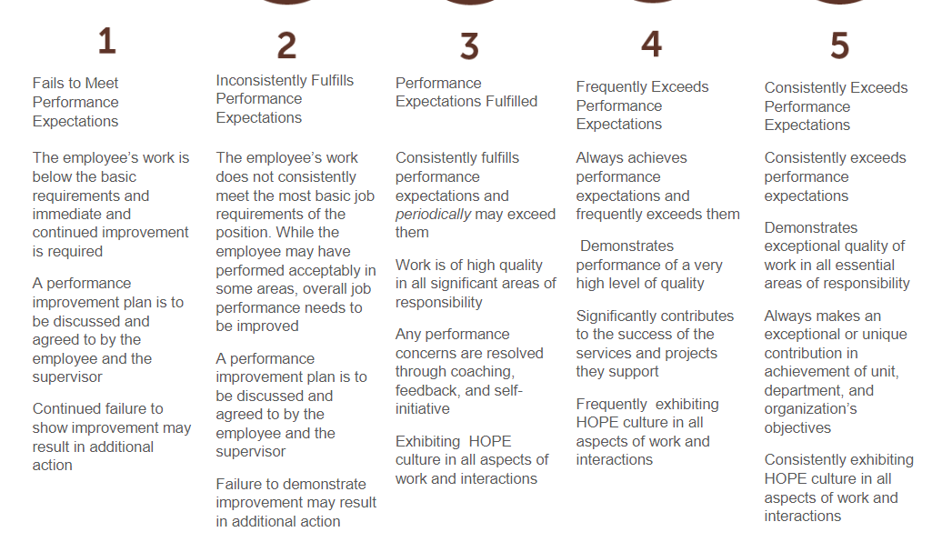
Please provide feedback on anything that your manager can start doing or do better to support you well during the next year.
Employee response: | Manager response:

Company values:
Please answer the following 2 questions about the employee’s contribution to HOPE International values.

- Rate the employee’s contribution to HOPE’s holistic development framework: 5C Model—Chris, Community, Character, Calling, Competencies.
Employee rating: | ☐ | ☐ | ☐ | ☐ | ☐
Employee rating: | Lives counter to the value | Rarely lives out the value | Sometimes lives out the value | Often lives out the value | Always lives out the value
Manager rating: | ☐ | ☐ | ☐ | ☐ | ☐
Manager rating: | Lives counter to the value | Rarely lives out the value | Sometimes lives out the value | Often lives out the value | Always lives out the value

- Rate the employee’s contribution to HOPE’s culture: PASSION—Prayer, Allegiance, Service, Stewardship, Innovation, Optimism, Nurturing.
Employee rating: | ☐ | ☐ | ☐ | ☐ | ☐
Employee rating: | Lives counter to the value | Rarely lives out the value | Sometimes lives out the value | Often lives out the value | Always lives out the value
Manager rating: | ☐ | ☐ | ☐ | ☐ | ☐
Manager rating: | Lives counter to the value | Rarely lives out the value | Sometimes lives out the value | Often lives out the value | Always lives out the value

